**Exercise: Setting up an Excel data source**

**Introduction**

By now, you know what the benefits of combining data sources are and how to set up a flat data source. In this exercise, you’ll put these new skills into practice by setting up a Microsoft Excel data source for Power BI, connecting to an Excel file from Power BI, selecting and importing data and creating a report in Power BI.

**Case Study**

Jamie, an Adventure Works executive, has asked you to prepare a report for the Sales department, displaying the details of any required order, including the product, unit price, order quantity, and discount rate for the annual review meeting. Each country manager shared a Microsoft Excel workbook containing the required data. It is your job to connect to the data sources and then combine them all into a single report!

**Resources**

To accomplish this exercise, you will need to ensure you have access to the following resources:

* Power BI Desktop.
* Table to import*:* This data will be imported into Power BI as part of the exercise.

[SalesOrderDetail](https://d3c33hcgiwev3.cloudfront.net/rNx--92nQmOKPI7hUo6YHA_96f2c956ed5840bdb2f973659bc9bfa1_SalesOrderDetail.xlsx?Expires=1709683200&Signature=LLZ4C240dQop16cgkNCIXUXDirmHDOdT27mKJ3JfAzS3SoVfCa4B5ZHrh~4tBqRJvl2U9kX7vam2TcC3rTavad3qDgmqFXOzO3ug3jHOAFrhbLs1LwYzMFaWo~5A6fFAduQQIiVXiWVe14N155Pfx7NSce5KMdTvQSYzvdBZeJ4_&Key-Pair-Id=APKAJLTNE6QMUY6HBC5A" \t "_blank)

[XLSX File](https://d3c33hcgiwev3.cloudfront.net/rNx--92nQmOKPI7hUo6YHA_96f2c956ed5840bdb2f973659bc9bfa1_SalesOrderDetail.xlsx?Expires=1709683200&Signature=LLZ4C240dQop16cgkNCIXUXDirmHDOdT27mKJ3JfAzS3SoVfCa4B5ZHrh~4tBqRJvl2U9kX7vam2TcC3rTavad3qDgmqFXOzO3ug3jHOAFrhbLs1LwYzMFaWo~5A6fFAduQQIiVXiWVe14N155Pfx7NSce5KMdTvQSYzvdBZeJ4_&Key-Pair-Id=APKAJLTNE6QMUY6HBC5A" \t "_blank)

**Instructions**

**Step 1: Download and prepare the file**

The first step is to ensure that your Excel file is saved on your computer, or that you have access to it through OneDrive for Business, personal OneDrive accounts, or SharePoint Team Sites. Ensure your files meet the following requirements:

* The dataset is provided as a flat file: Your workbook must not have any total rows or columns.
* All data in each column should be of the same type: Whether it is dates, text or currency, each column must contain the same type of data.
* The file is in an easily readable table format. It does not contain pivot tables or matrix formats
* A space-free name: Give your table a name that is easy to remember. Just remember that the name cannot contain any spaces.

**Step 2: Get data**

Power BI Desktop provides the ability to connect with various data sources, ranging from basic sources such as Microsoft Excel files to more complex ones.

* Since your assigned task is to connect to the data sources required, let's connect to them. Choose the required data type from the list.
* Navigate to the location where your Excel file is saved.
* Choose the worksheet(s) and table(s) you want to import in the Navigator window.
* Click Load. This will import your Excel data into Power BI. **Tip:** You can inspect the data in the Table View (also known as the Data View) by clicking the table icon on the left sidebar.
* Save your Power BI project.

**Conclusion**

Congratulations, you have set up an Excel data source in Power BI! Remember that while Excel is a great starting point, Power BI offers many more powerful data analysis and visualization tools.

**Exemplar: Setting up an Excel data source**

In the exercise Setting up an Excel Data Source*,* you had to set up a Microsoft Excel data source for Power BI, connect to an Excel file from Power BI, select and import data and create a report in Power BI.

This reading presents the process, accompanied by screenshots for easy comparison with your own copy.

Before we start, please take note of the following important information.

**Power BI Desktop User Interface**

Power BI Desktop is updated and released on a monthly basis, incorporating customer feedback and new features. You might experience changes in the Power BI Desktop User Interface (UI) that have taken place after the development of this training content. As a result, the screenshots in the videos, readings, or exercises might not align exactly with how you experience the UI. However, please note that these changes do not impact the functionalities of the UI. Hence, you will still be able to perform all the steps shown in that video, reading, or exercise.

**Step 1: Understand the context**

The first step is to ensure that your Excel file is saved on your computer, or that you have access to it through OneDrive for Business, personal OneDrive accounts, or SharePoint Team Sites. Ensure your files meet the following requirements:

* The dataset is provided as a flat file: Your workbook must not have any total rows or columns.
* All data in each column should be of the same type: Whether it is dates, text or currency, each column must contain the same type of data.
* The file is in an easily readable table format. It does not contain pivot tables or matrix formats
* Easily readable table format: no pivot tables or matrix formats are accepted.
* A space-free name: Give your table a name that is easy to remember. Just remember that the name cannot contain any spaces.

**Step 2: Get data**

Power BI Desktop provides the ability to connect with various data sources, ranging from basic sources such as Microsoft Excel files to more complex ones.

1. Once you have Power BI Desktop open, select the **Get Data** option on the **Home** tab. This will open the **Get Data** window where you can choose the data source you want to connect to.

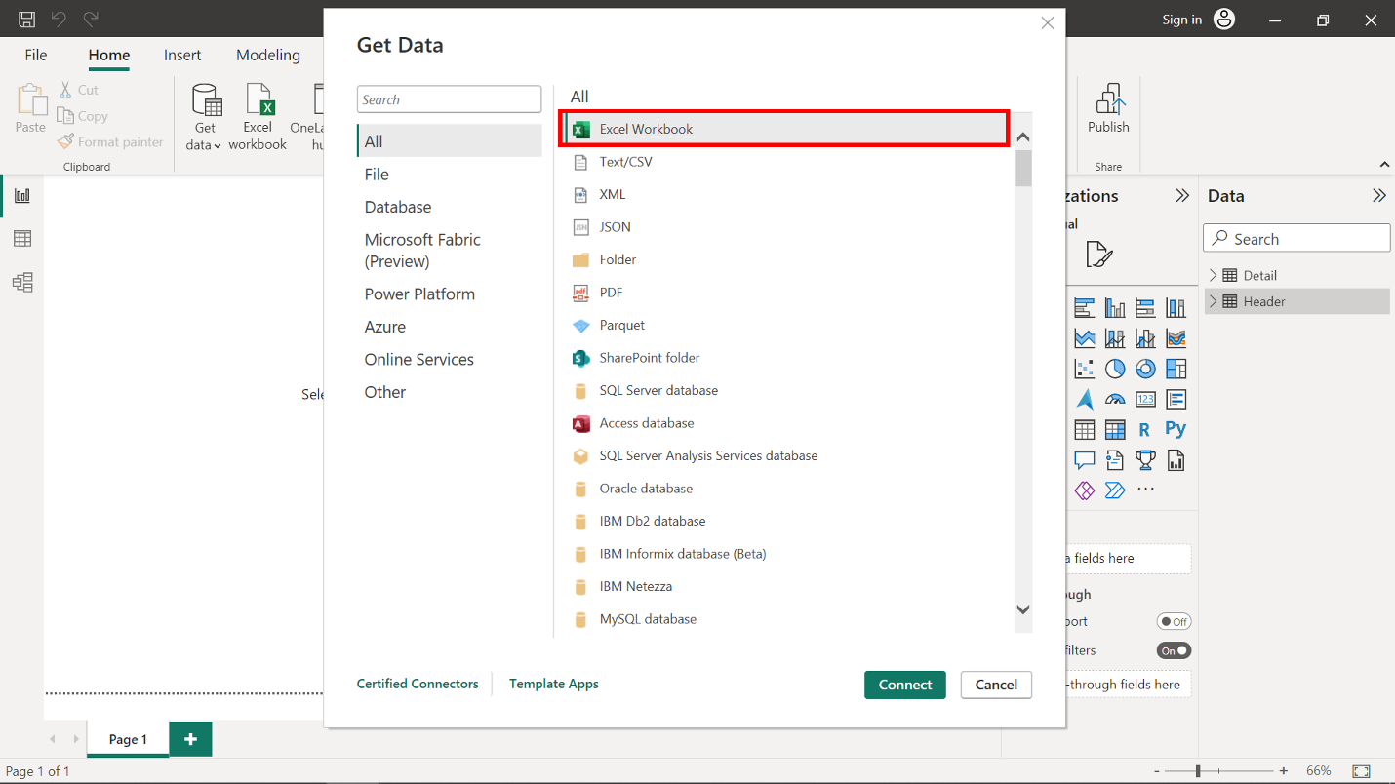

1. Choose **Excel** from the list of data sources where you can navigate to the location where your Excel file is saved.

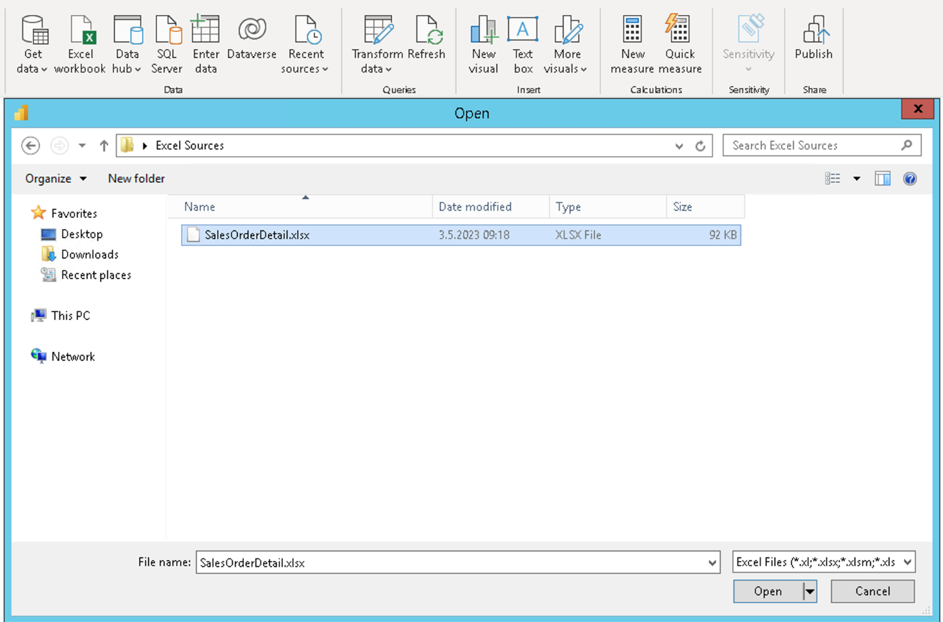

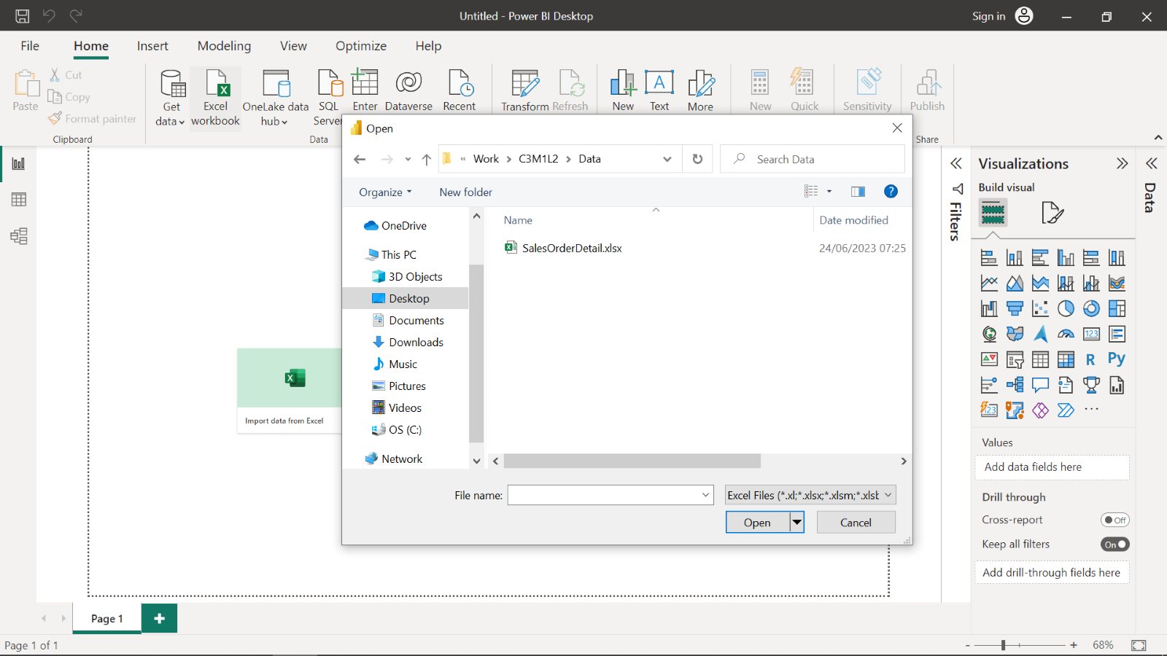

1. From the **Navigator** window you can choose the worksheet(s) and table(s) you want to import.

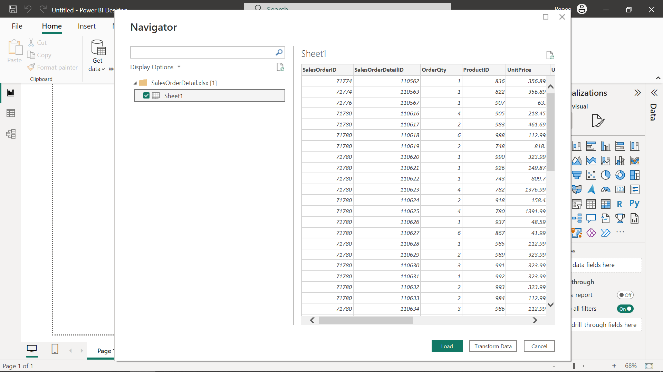

Then select **Load**. This will import your Excel data into Power BI.

Click the Save button in the top-left corner to save the project. Power BI will display a message indicating that you are ready to build visuals now that the data has successfully imported.

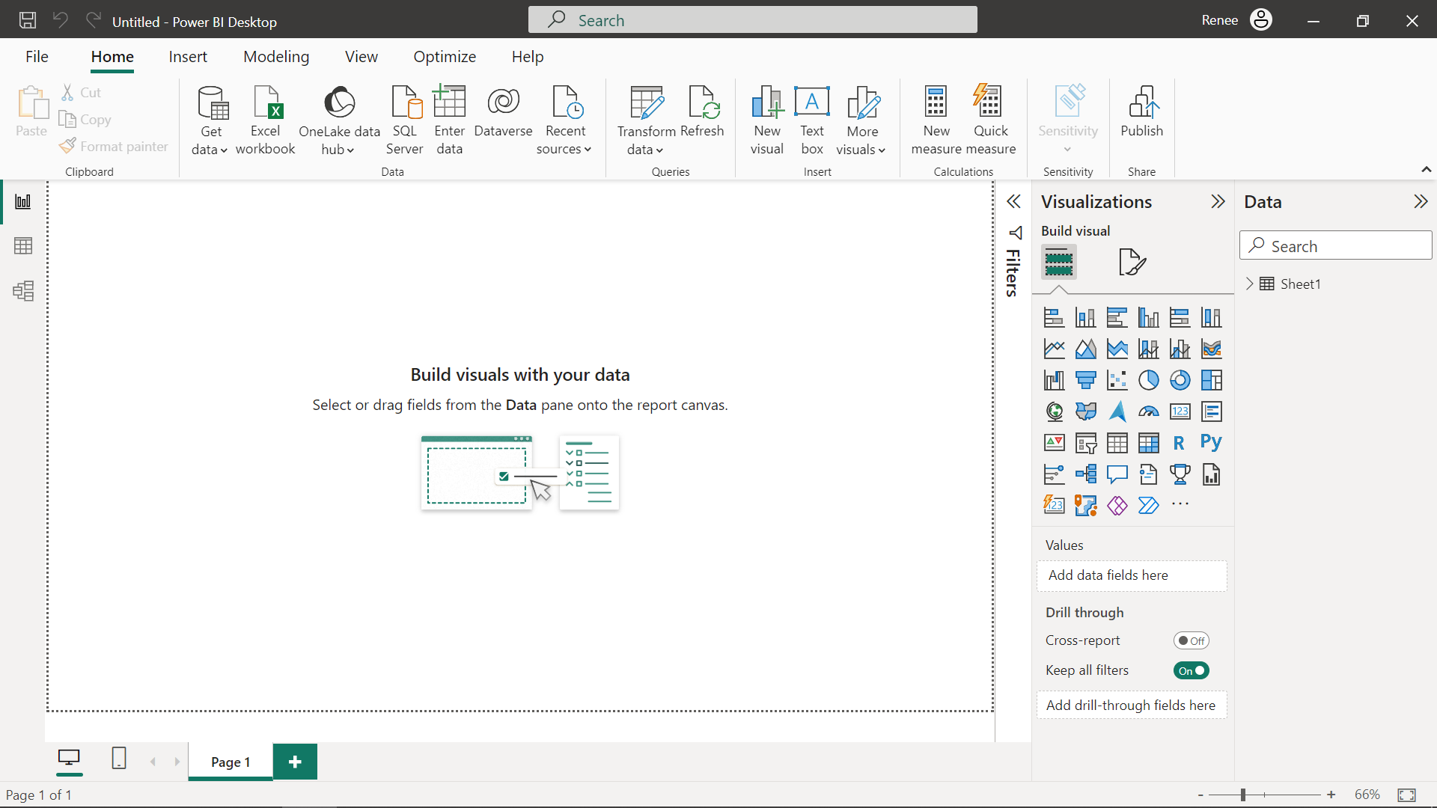

**Completed examples**

Compare your work with our finished version. Below is the Table View that is accessible by clicking on the table icon on the left side of the Power BI interface.

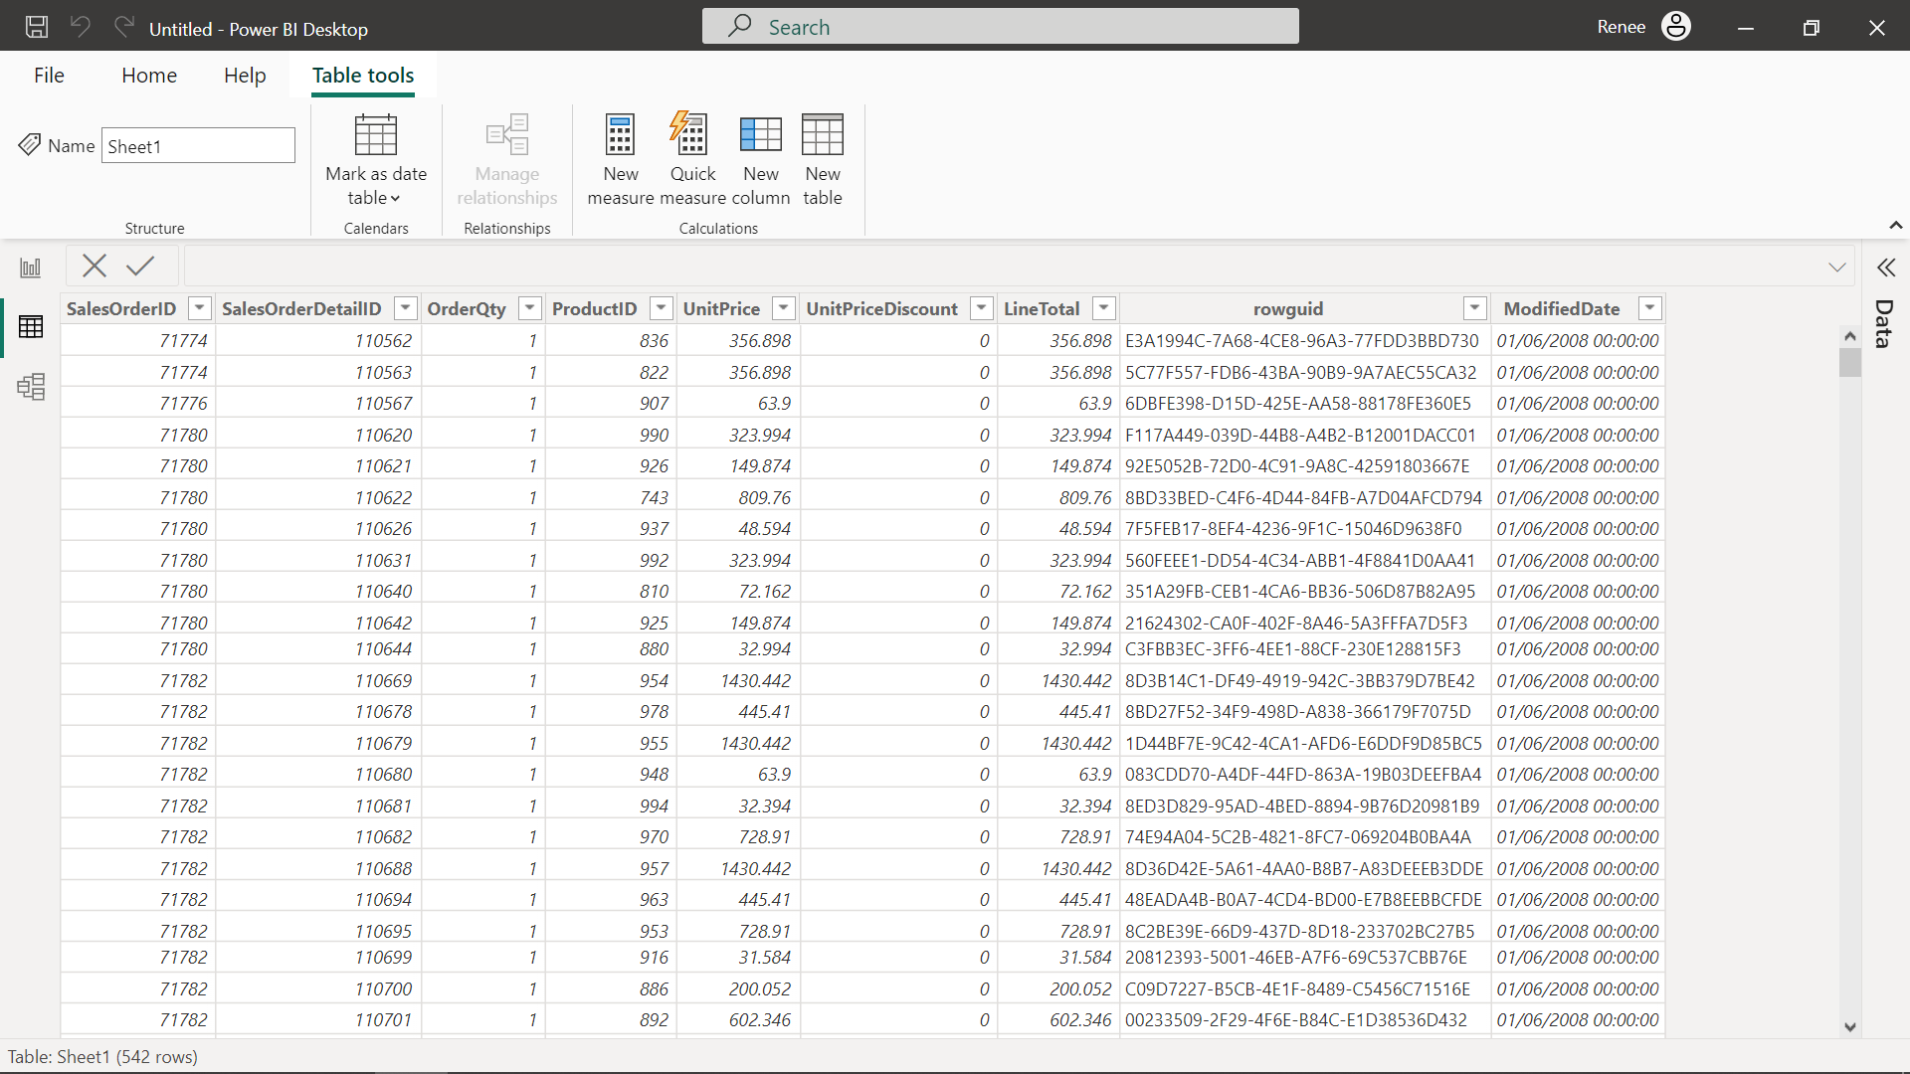

**Conclusion**

Congratulations! You have successfully completed this exercise. You now know how to set up an Excel data source in Power BI.